# Artifacts and Testware

## 1-Artifacts

### What Are Artifacts

**# Source**: **Chatgpt (GPT-5-Standard) at [8/14/2025]**

In software development and testing, **artifacts** are **any by-products or deliverables created during the software development lifecycle (SDLC)**.  
 They can be **documents, models, diagrams, or even code** — basically, anything produced as part of the process.

### Types of Artifacts

#### 1. Process Artifacts

**# Source**: **Chatgpt (GPT-5-Standard) at [8/14/2025]**

* Describe how the project is organized and managed.
* Examples:  
  + Project plans
  + Test strategies
  + Risk assessment documents

#### 2. Product Artifacts

**# Source**: **Chatgpt (GPT-5-Standard) at [8/14/2025]**

* Represent the actual product or parts of it.
* Examples:  
  + Requirements documents
  + Source code
  + Design diagrams
  + UI mockups

#### 3. Test Artifacts

**# Source**: **Chatgpt (GPT-5-Standard) at [8/14/2025]**

* Related specifically to testing activities.
* Examples:  
  + Test plans
  + Test cases
  + Test scripts
  + Bug reports

### Examples in Context

**# Source**: **Chatgpt (GPT-5-Standard) at [8/14/2025]**

* **Before coding:** Requirements specification (artifact)
* **During design:** UML diagrams (artifact)
* **During implementation:** Source code files (artifact)
* **During testing:** Test case documents and defect logs (artifact)
* **After release:** User manuals (artifact)

### Why Artifacts Matter

**# Source**: **Chatgpt (GPT-5-Standard) at [8/14/2025]**

* Provide **documentation** for future maintenance.
* Help ensure **traceability** (linking requirements → test cases → code).
* Serve as **communication tools** between teams.
* Can be **reviewed in static testing** to catch defects early.

💡 **Analogy:** In a construction project, artifacts are like the blueprints, safety inspection reports, and material lists — not the building itself, but essential for building it right.

## 2-Testware

### What is Testware

**# Source**: **Chatgpt (GPT-5-Standard) at [8/12/2025]**

**Testware** = all the **artifacts** (things) produced during the testing process that are **needed to design, execute, and manage tests**.

It’s like “software” but for **testing** — created **by testers** and **for testing**.

### Examples of Testware

**# Source**: **Chatgpt (GPT-5-Standard) at [8/12/2025]**

* **Test plans** (how testing will be done)
* **Test cases** & **test scripts**
* **Test data** (input values for tests)
* **Test suites** (grouped tests)
* **Test environments** (configured systems for testing)
* **Defect reports**
* **Traceability matrices** (map between requirements and tests)
* **Test summary reports**

### Key points

**# Source**: **Chatgpt (GPT-5-Standard) at [8/12/2025]**

* **Purpose:** Help in planning, designing, executing, and reporting tests.
* **Ownership:** Usually created and maintained by testers/QA team.
* **Not part of final product** — but still important deliverables.
* **Can be reused** in future testing cycles or regression testing.

💡 **Simple analogy:**

If testing is a cooking process,

* **Software** = the actual meal (final product)
* **Testware** = the recipe, shopping list, cooking instructions, taste test results, and kitchen setup used to make sure the meal turns out right.

### Traceability between the Test Basis and Testware

**# Source**: **Chatgpt (GPT-5-Standard) at [8/12/2025]**

**Traceability between the Test Basis and Testware** means being able to clearly **link each testing artifact (Testware)** back to the **original source (Test Basis)** so you can prove:

* **Why** you tested something
* **Where** a test requirement came from
* **What impact** a change in requirements will have on tests

#### Key Concepts

**# Source**: **Chatgpt (GPT-5-Standard) at [8/12/2025]**

1. **Test Basis** = Source of truth (requirements, designs, user stories, regulations).
2. **Testware** = All the testing artifacts you produce (test plans, test cases, scripts, test data, etc.).
3. **Traceability** = Mapping between these two so there’s no guesswork.

#### Why it’s important

**# Source**: **Chatgpt (GPT-5-Standard) at [8/12/2025]**

* Ensures **complete coverage** (no missed requirements).
* Helps in **impact analysis** when requirements change.
* Shows **compliance** for audits or regulated industries.
* Detects **orphan tests** (tests with no related requirement).

#### How It Works

**# Source**: **Chatgpt (GPT-5-Standard) at [8/12/2025]**

Usually implemented through a **Traceability Matrix**:

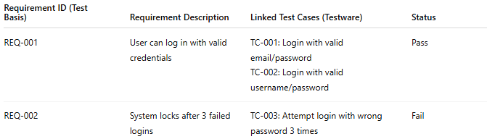

| **Requirement ID (Test Basis)** | **Requirement Description** | **Linked Test Cases (Testware)** | **Status** |
| --- | --- | --- | --- |
| REQ-001 | User can log in with valid credentials | TC-001: Login with valid email/password TC-002: Login with valid username/password | Pass |
| REQ-002 | System locks after 3 failed logins | TC-003: Attempt login with wrong password 3 times | Fail |

#### Example in Practice

**# Source**: **Chatgpt (GPT-5-Standard) at [8/12/2025]**

* **Test Basis**: Requirement REQ-045 — “Search results must be returned in under 2 seconds.”
* **Testware**:  
  + Test Case TC-123 — Measure search response time for keyword “Laptop”.
  + Test Data — "Laptop" keyword, timing script.
* **Traceability**: TC-123 in the matrix links directly to REQ-045 so if REQ-045 changes (e.g., to 3 seconds), you instantly know which test cases to update.

### Difference between Artifacts and Testware

**# Source**: **Chatgpt (GPT-5-Standard) at [8/14/2025]**

Here’s the clear breakdown between **Artifacts** and **Testware** so you can see the relationship and differences:

#### 1. Artifacts

**# Source**: **Chatgpt (GPT-5-Standard) at [8/14/2025]**

* **Definition:** Any **by-product, document, or deliverable** created during the software development lifecycle (SDLC), whether for requirements, design, coding, testing, or deployment.
* **Scope:** **Broad** — includes *all* work products, not just testing-related ones.
* **Examples:**
  + Requirements Specification Document (SRS)
  + UML Diagrams
  + Source Code
  + Test Cases
  + Bug Reports
  + Release Notes

#### 2. Testware

**# Source**: **Chatgpt (GPT-5-Standard) at [8/14/2025]**

* **Definition:** A **subset of artifacts** — specifically, all **materials produced during the testing process** that are needed to plan, design, execute, and evaluate tests.
* **Scope:** **Narrow** — only includes testing-related items.
* **Examples:**
  + Test Plans
  + Test Cases
  + Test Data
  + Test Scripts
  + Defect Logs
  + Test Reports

#### Key Difference Table

**# Source**: **Chatgpt (GPT-5-Standard) at [8/14/2025]**

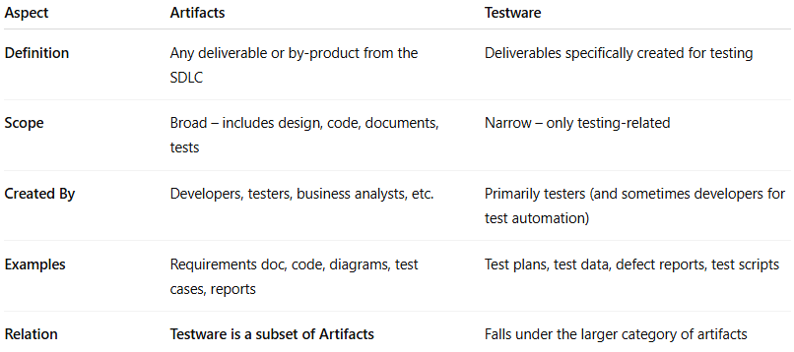

| **Aspect** | **Artifacts** | **Testware** |
| --- | --- | --- |
| **Definition** | Any deliverable or by-product from the SDLC | Deliverables specifically created for testing |
| **Scope** | Broad – includes design, code, documents, tests | Narrow – only testing-related |
| **Created By** | Developers, testers, business analysts, etc. | Primarily testers (and sometimes developers for test automation) |
| **Examples** | Requirements doc, code, diagrams, test cases, reports | Test plans, test data, defect reports, test scripts |
| **Relation** | **Testware is a subset of Artifacts** | Falls under the larger category of artifacts |

💡 **In short:**

* **Artifacts** = Everything created during the project.
* **Testware** = The testing part of those artifacts.